**Department of Electronics and Telecommunication Engineering**

**Module wise University Questions**

**(First Half of 2023)**

**Class/Sem: BE/VIII Branch: EXTC**

**Subject: OCN**

**Module 5: Packet Switching and Access Networks**

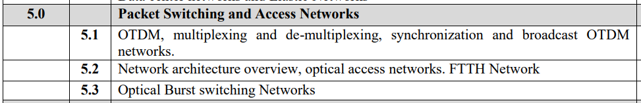

**May 2019**

1. Explain bit interleaving and packet interleaving techniques used in OTDM [10]
2. Explain in brief different types of PON (passive optical network) architecture [10]

**Dec 2018**

1. Explain in brief different types of PON (passive optical network) architecture [10]

**May 2018**

1. Explain OTDM in detail [05]
2. Write short note on: optical access network [05]

**Dec 2017**

1. Write short note on: optical access network [10]

**May 2017**

1. Explain OTDM in detail [10]

**Dec 2016**

1. What do you mean by bit interleaving and packet interleaving [07]
2. Write short note on: optical access network [05]

**May 2016**

1. Explain Optical access networks (OAN)[10]
2. Short Note on: a. OTDM[10]
3. Short Note : c. Crosstalk[05]
4. What is the concept of bit interleaving and packet interleaving [05]
5. Comment on optical assess networks [05]

**Dec 2015**

1. Explain optical access networks [10]